https://www.nlog.nl/nlog-mapviewer/brh/2641658759?lang=nl
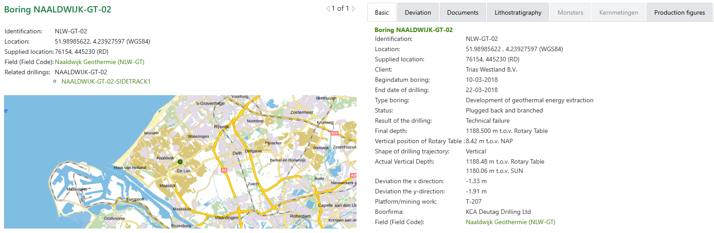
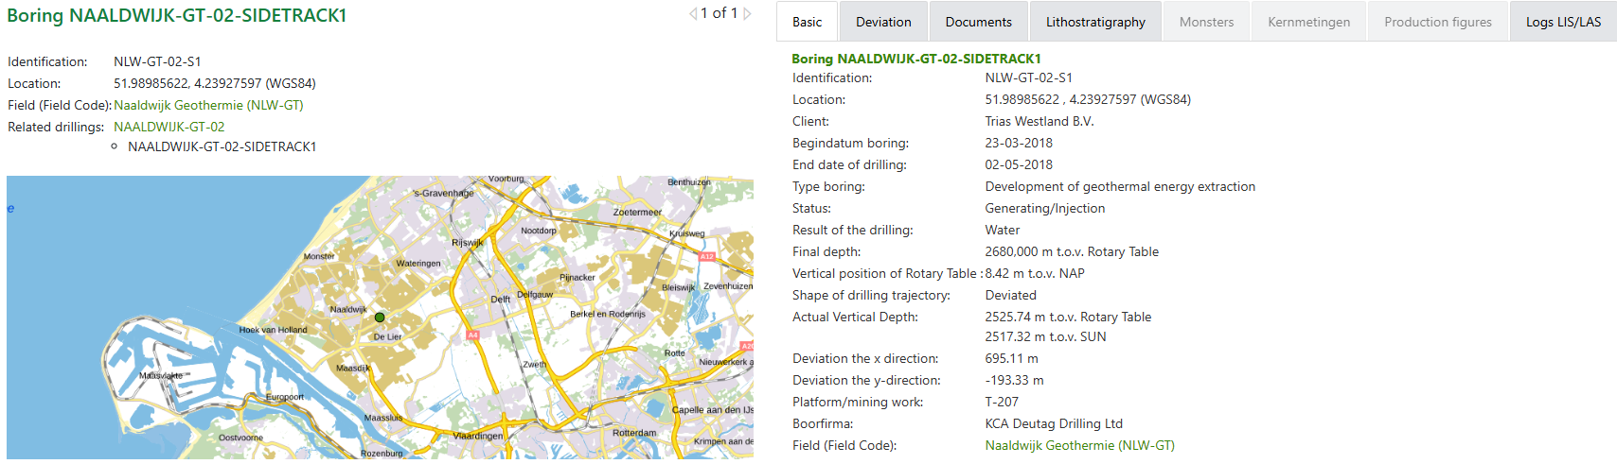

Boring NAALDWIJK-GT-02
Category | Document
Documents with profile data of the borehole | Deviation Surveys(02 May 2018) # 1  Deviation Surveys(02 May 2018) # 2  Deviation Surveys(02 May 2018) # 3  Deviation Surveys(02 May 2018) # 4
Borehole sample research reports | DEVLI project: Stratigraphy and tectonostratigraphy of the Delfland and Vlieland subgroups, Upper Jurassic and Lower Cretaceous - Broad Fourteens Basin, West Netherlands Basin and neighbouring areas. (20 Nov 2024)

Boring NAALDWIJK-GT-02-SIDETRACK1
Category | Document
Borehole/Well - Final Report | End of Well Report - Workover(22 Jul 2019)  End of Well Report(20 Jul 2018) # 1  End of Well Report(20 Jul 2018) # 2  End of Well Report(20 Jul 2018) # 3
Documents with borehole measurements | MWD - Gamma Ray Composite(1801-2386)(17 Apr 2018) # 1  MWD - Gamma Ray Composite(1801-2386)(17 Apr 2018) # 2  MWD - Gamma Ray(123-1106)(27 Mar 2018) # 1  MWD - Gamma Ray(123-1106)(27 Mar 2018) # 2  MWD - Gamma Ray(2334-2681)(28 Apr 2018) # 1  MWD - Gamma Ray(2334-2681)(28 Apr 2018) # 2
Documents with profile data of the borehole | Deviation Surveys(02 May 2018) # 1  Deviation Surveys(02 May 2018) # 2  Deviation Surveys(02 May 2018) # 3  Deviation Surveys(02 May 2018) # 4  Formation Tops Prognosed vs Actual(02 May 2018)  Technical Log (Composite Log)(02 May 2018)
Documents with test result borehole | Analysis of Well Test(30 Jun 2018) # 1  Analysis of Well Test(30 Jun 2018) # 2  Interference in NLW-GT-01 of Test NLW-GT-02(30 Jun 2018) # 1  Interference in NLW-GT-01 of Test NLW-GT-02(30 Jun 2018) # 2  Interference in NLW-GT-01 of Test NLW-GT-02(30 Jun 2018) # 3  Well Test(01 Jun 2018) # 1  Well Test(01 Jun 2018) # 2  Well Test(01 Jun 2018) # 3
Borehole sample research reports | DEVLI project: Stratigraphy and tectonostratigraphy of the Delfland and Vlieland subgroups, Upper Jurassic and Lower Cretaceous - Broad Fourteens Basin, West Netherlands Basin and neighbouring areas. (20 Nov 2024)

